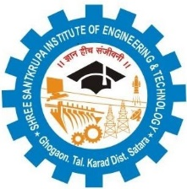
IQAC/2018/10

Shree Santkrupa Shikshan Sanstha’s
Shree Santkrupa Institute of Engineering and Technology
Ghogaon (Shivajinagar), Tal-karad, Dist-Satara

Department of Mechanical Engineering
Notice & Timetable
(Progressive Test-I)

Date: 17/04/2023

All the faculties concern to Mechanical Department is hereby informed that Progressive test-I for second year class is scheduled during 20/04/2023 to 22/04/2023.So please submit the soft copy of Question Papers of respective subjects as per the decided pattern (Assignment based, maximum 8 questions) till 19/04/2023. Question paper should be concern of 2 units of each subject syllabus.

Date | Time | Name of subject  (SE)
20/04/2023 | 01.30 PM to 02.30 PM | Numerical Methods in Engineering
20/04/2023 | 02.45 PM to 03.45 PM | Strength of Materials
21/04/2023 | 01.30 PM to 02.30 PM | Manufacturing Processes – I
21/04/2023 | 02.45 PM to 03.45 PM | Basic Human Rights
22/04/2023 | 10.00 AM to 11.00 AM | Theory of Machines-I

Exam coordinator HOD

