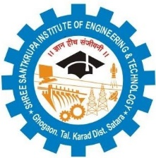
IQAC/2018/11

Shree Santkrupa Shikshan Sanstha’s
Shree Santkrupa Institute of Engineering and Technology
Ghogaon (Shivajinagar), Tal-karad, Dist-Satara

Department of Mechanical Engineering
Notice & Timetable
(Progressive Test-I)

Date: 17/04/2023

All the students of second year class are hereby informed that that Progressive test-I is scheduled during 20/04/2023 to 22/04/2023 and is going to conduct as per the following rules.
1. Examination is going to conduct as per timetable provided by department.
2. Exam will conduct through offline mode & decided pattern for exam is assignment type.
3. Syllabus for examination is 2 units of each subject.
4. Time provided will be one hour.
5. First three lectures will be conduct as per timetable.

Date | Time | Name of subject  (SE)
20/04/2023 | 01.30 PM to 02.30 PM | Numerical Methods in Engineering
20/04/2023 | 02.45 PM to 03.45 PM | Strength of Materials
21/04/2023 | 01.30 PM to 02.30 PM | Manufacturing Processes – I
21/04/2023 | 02.45 PM to 03.45 PM | Basic Human Rights
22/04/2023 | 10.00 AM to 11.00 AM | Theory of Machines-I

Exam coordinator HOD

