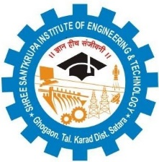
IQAC/2018/17

Shree Santkrupa Shikshan Sanstha’s
Shree Santkrupa Institute of Engineering and Technology
Ghogaon (Shivajinagar), Tal-karad, Dist-Satara

Seminar/Workshop/Event Notice
Date:

Academic Year: To:
Name of the event:
Date of the event: Time:
Venue:

---------------------------------------------------------------------------------------------------------------------------------------------------------------------------------------------------------------------------------------------------------------------------------------------------------------------------------------------------------------------------------------------------------------------------------------------------------------------------------------------------------------------------------------------------------------------------------------------------------------------------------------------------------------------------------------------------------------------------------------------------------------------------------------------------------------------------------------------------------

Name and Sign of Coordinator Principal

