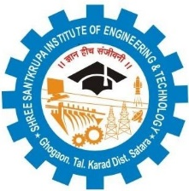
IQAC/2018/19
Shree Santkrupa Shikshan Sanstha’s
Shree Santkrupa Institute of Engineering and Technology
Ghogaon (Shivajinagar), Tal-karad, Dist-Satara

Seminar/Workshop/Event Attendance

Academic Year: - Date: - 16/02/2023
Name of Event:
Sr. No. | Name of Participant | Signature

Name and Sign of Coordinator

