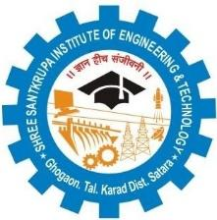 | IQAC/2018/25  Shree Santkrupa Shikshan Sanstha’s  Shree Santkrupa Institute of Engineering and Technology  Ghogaon (Shivajinagar), Tal-karad, Dist-Satara
Date: / /20____
Maintenance Requirement
Academic Year: 2022-23 Semester-

Sr. No. | Name of Lab/classroom/Venue |  | Details of Maintenance
 |  | Civil Work Maintenance | Electrical  Maintenance | Furniture Maintenance | Computer Maintenance | Equipment / Any other Maintenance
1.
2.
3.
4.
5.

Summary of Material required

Sr.  No. | Particulars | Quantity
1
2
3

HOD

