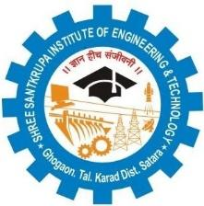
IQAC/2018/05

Shree Santkrupa Shikshan Sanstha’s
Shree Santkrupa Institute of Engineering and Technology
Ghogaon (Shivajinagar), Tal-karad, Dist-Satara

NOTICE

Date:

Academic Year: TO:

sava- ivadyaaqyaa-Mnaa kLivaNyaat yaoto kI Internal Sports id.21.02.2023 pasaUna sau$ haot AsaUna %yaacao vaoLap~k KalaIla p`maaNao Aaho trI KalaIla KoLacyaa iTma k^PTnanaI Aaplyaa saMbaMQaIt iTmacaI yaadI KalaIla Co-ordinator kDo dyaavaI.
spQao-maQyao vaoLonausaar badla krNyaacao AiQakar Sports kimaTIlaa AsatIla.%yaamauLo sava- KoLaDUMnaI tsaoca sava- saMGaaMnaI spQao-cyaa p`%yaok idvaSaI hjar rahNao baMQanakark Aaho.jar eKadI iTma hjar nasaola tr tI iTma baad GaaoSaIt krNyaat yao[-la.yaacaI sava- ivadyaaqyaa-MnaI naaoMd GyaavaI.
Winner Department laa General Championship doNyaat yaoNaar Aaho

Principal / HOD/ Admin/Staff

