A PROJECT REPORT
ON
“ANALYSIS THE MANUFACTURING SYSTEM AND INCREASE PRODUCTIVITY BY USING SIMULATION SOFTWARE”
SUBMITTED IN PARTIAL FULFILLMENT OF
THE REQUIREMENT FOR THE AWARD OF DEGREE OF BACHELOR OF ENGINEERING IN

MECHANICAL ENGINEERING
OF

DR. BABASAHEB AMBEDKAR TECHHNOLOGICAL UNIVERSITY, LONERE.
SUBMITTED BY
MS. HIRAWALE SNEHAL RAJENDRA MS. PATIL DHANSHREE VIJAY
MS. SHEWALE MEGHA KRISHNA

UNDER THE GUIDANCE OF
PROF. MR. BHOSALE B. Y.

DEPARTMENT OF MECHANICAL ENGINEERING
SHREE SANTKRUPA INSTITUTE OF ENGINEERING & TECHNOLOGY, GHOGAON, TAL- KARAD, DIST.-SATARA (415111)
Academic Year
2023-24

SHREE SANTKRUPA INSTITUTE OF ENGINEERING & TECHNOLOGY (GHOGOAN).

DEPARTMENT OF MECHANICAL ENGINEERING

This is to certify that, Mr./ Ms. Patil Dhanashree Vijay has successfully completed the project work entitled, “ANALYSIS of THE MANUFACTURING SYSTEM AND INCREASE PRODUCTIVITY BY USING SIMULATION SOFTWARE”. This work is being submitted in partial fulfillment of the requirements for the award of Bachelor of Technology in Mechanical Engineering of Dr. Babasaheb Ambedkar Technological University Lonere. He/ She has carried out the work under my supervision and guidance, academic year 2023-24.

Date:
Place: SSIET, Ghogoan

Prof. Mr. Bhosale B.Y. Prof. Mr. Bhosale B.Y.
(Project Guide) (Head of Department)

SHREE SANTKRUPA INSTITUTE OF ENGINEERING & TECHNOLOGY (GHOGOAN).

DEPARTMENT OF MECHANICAL ENGINEERING

This is to certify that, Mr./ Ms. Shewale Megha Krushna has successfully completed the project work entitled, “ANALYSIS of THE MANUFACTURING SYSTEM AND INCREASE PRODUCTIVITY BY USING SIMULATION SOFTWARE”. This work is being submitted in partial fulfillment of the requirements for the award of Bachelor of Technology in Mechanical Engineering of Dr. Babasaheb Ambedkar Technological University Lonere. He/ She has carried out the work under my supervision and guidance, academic year 2023-24.

Date:
Place: SSIET, Ghogoan

Prof. Mr. Bhosale B.Y. Prof. Mr. Bhosale B.Y.
(Project Guide) (Head of Department)

SHREE SANTKRUPA INSTITUTE OF ENGINEERING & TECHNOLOGY (GHOGOAN).

DEPARTMENT OF MECHANICAL ENGINEERING

This is to certify that, Mr./ Ms. Hirwale Snehal Rajendra has successfully completed the project work entitled, “ANALYSIS of THE MANUFACTURING SYSTEM AND INCREASE PRODUCTIVITY BY USING SIMULATION SOFTWARE”. This work is being submitted in partial fulfillment of the requirements for the award of Bachelor of Technology in Mechanical Engineering of Dr. Babasaheb Ambedkar Technological University Lonere. He/ She has carried out the work under my supervision and guidance, academic year 2023-24.

Date:
Place: SSIET, Ghogoan

Prof. Mr. Bhosale B.Y. Prof. Mr. Bhosale B.Y.
(Project Guide) (Head of Department)

ACKNOWLEDGMENT

We take this opportunity to express our sincere gratitude towards our guide Prof. Mr. Bhosale B.Y. for his valuable guidance and encouragement throughout the project work. His inspiration and constant endeavors to cooperate in analyzing the documents and data resulted in the successful completion of my project work.
We would like to special thanks to Principal, Dr. Swanand B. Kulkarni for providing library and laboratory facilities.
We are also thankful to all Teaching and non-teaching staff of the Mechanical Engineering Department for supporting us directly or indirectly throughout our time at Shree Santkrupa Institute of Engineering & Technology.
We are very thankful to our parents for their unconditional love and support in bringing this dissertation into reality.

Ms. Patil Dhanashri Vijay
Ms. Shewale Megha Krishna
Ms. Hirawale Snehal Rajendra

INDEX

CONTENT PAGE NO.
List of figures I

List of tables II
List of charts III
Abstract IV
- . INTRODUCTION 1
  - Overview 1
  - Problem Statement 2
  - Objectives of Study 2
  - Flow of work & methodology 2
- . LITERATURE REVIEW 3
  - Literature of Review 3
  - Literature survey 3
- PROJECT ACTIVITIES 7
  - Simulation in Manufacturing 7
    - Overview 7
    - Flexsim software 7
  - Steps of modeling and simulation 8
  - Scope 9
  - Features of simulation software 10
    - Advantages 10
    - Disadvantages 10
- PERFORMANCE ANALYSIS: SIMULATION RESULTS 11
- Boring bar 11
  - Steps for boring bar 11
  - Process layout using simulation software 12
  - Simulate existing layout using simulation software 15
  - State gantt chart 16
  - State pie chart 16
  - New development 17
    - Maximum time-consuming 18
- Four-hole relation gauge 20
  - Steps for four-hole relation gauge 20
  - Process layout using simulation software 20
  - Simulation of existing layout using flexsim software 24
  - State Gantt Chart 25
  - State pie chart 26
  - New development 27
    - Maximum time-consuming 27
- RESULTS 29
  - Results analysis 29
  - Profit comparison and increase in profitability Table 30
    - Productivity Before Simulation 30
    - Productivity after Simulation 30
    - Profit comparison 31
- CONCLUSION 32
- REFERENCES 33
- PAPER PUBLICATION 34
- PROJECT GROUP PHOTO 35

LIST OF FIGURES

FIGURE NO. | TITLE | PAGE NO
Figure 3.2 | Steps of modeling & simulation | 9
Figure 4.1 | Company layout | 11
Figure 4.2 | Boring bar process layout | 12
Figure 4.2.1 | Boring bar | 13
Figure 4.3 | Existing plant layout | 15
Figure 4.6 | New development | 18
Figure 4.6.1 | Maximum time consuming | 19
Figure 4.8 | Process layout using simulation software | 20
Figure 4.8.1 | Four-hole relation gauge | 22
Figure 4.9 | Existing plant layout | 25
Figure 4.12 | New development | 27
Figure 4.12.1 | Maximum time consuming | 28

LIST OF TABLES

TABLE NO | ILLUSTRATION | PAGE NO
Table 4.2.1 | Machine to machine distance | 14
Table 4.2.2 | Machining data | 14
Table 4.6 | Working machine in percentage | 17
Table 4.8.1 | Machining data | 23
Table 4.8.2 | Machine-to-machine distance | 24
Table 4.11 | Working machine in percentage | 26
Table 5.1.1 | Result for boring bar | 29
Table 5.1.2 | Result for four-hole relation gauge | 30
Table 5.2 | Before simulation | 30
Table 5.2.2 | After simulation | 31
Table 5.2.3 | Profit comparison | 31

LIST OF CHARTS

CHART NO | ILLUSTRATION | PAGE NO
Chart 4.4 | State gantt chart | 16
Chart 4.5 | State pie chart | 16
Chart 4.10 | State gantt chart | 25
Chart 4.11 | State pie chart | 26

ABSTRACT

Improvement of manufacturing system is must do process due to development of manufacturing technology and increase in customer needs. Due to development of technology, companies need to do improvement of their current system in order to survive in competition. This study will analyse overall productivity and identified critical process that consider bottleneck. This study also will quantify impact of batch capacity in manufacturing productivity. Computer aided simulation software will be used as main method.
Data of manufacturing system will be collected and will be used as input in simulation software. Altering several parameters such as machines quantity and batch size helps author to studied final output. It helps author reduce time to do trial for new design as simulation software will done based on real time and system performance will be address to help improvise new design. Simulation also can be applied at both the justification phase and design phase. By using this method, critical area can be identified in manufacturing system and explore several solutions based on different scenario.

CHAPTER 1: INTRODUCTION

OVERVIEW

At present’s days, most of the small and medium scale manufacturing industries is highly technically developed and more complicated. Therefore, such industries system is not properly developed or designed with scientific solution. So they are required scientific and proper stable technique to reduce costly mistakes or errors. Simulation is one of the techniques for analyzing a production system without having actual experiment on the system. The simulation model guided for improvement on machine performance, material movement and process sequence. Hence it provides clear picture to the management for taking decision whether the investment is useful for it or not. As market demand keep increasing and development of manufacturing technology, competition in manufacturing industries is tougher. Many companies had invested in productivity improving efforts in order to meet their customer demand. The performance of production measures production’s ability to generate income. In modern business, capital and labor are both become main constraint. Hence, by maximizing both resources allow industry to achieve higher productivity. Productivity enhancements come from technology advances, such as computers and the internet, supply chain and logistics improvements, and increased skill levels within the workforce.
In order to improve quality and productivity, continuous improvement had to be made to current process or service. Companies that have ability to effectively implement on-going product, service, and process improvisation has an advantage to stay competitive. Before any improvement to manufacturing system can be done, it is important to study the current situation of current process and determine problems occur in the system.
In this advancing world, manufacturing technology keep improving by time, manufacturing systems and processes are becoming complex and are increasingly characterized by high levels of automation and integration, greater demands on performance, and various forms of human supervisory control and consists of many discrete operations that occur randomly. Simulation modeling will be used as primary method to analyze current system and highlight critical area that need improvisation therefore helps in increasing overall productivity.

PROBLEM STATEMENT

After conducting survey, it is found that in actual industrial scenario, shop floor problems are tackled with less scientific approach. Perfect Components is an industry involved in manufacturing of various components located at Karad MIDC. The company is facing with various problems like complicated plant layout, less space for material handling, repetitive material backtracking, more component cycle time. considering these difficulties, present project work aims at tackling above problems in more scientific manner by taking the help of tools like simulation software.

OBJECTIVE OF STUDY
    - To develop simulation model of current manufacturing system using FLEXSIM simulation software.
    - To identify and fix bottleneck stations in manufacturing system.
    - To reduce the total manufacturing cycle time of components.
    - To improve the manufacturing plant layout.
    - To reduce material movement distance and back tracking.

FLOW OF WORK AND METHODOLOGY:

    - Research on project topic.
    - Discuss about the project to the guide.
    - Study and analysis research paper related to project topic.
    - Identify and meet stakeholders for approval in company.
    - Study and examine industry layout and identify their problems.
    - Sets goals and objective.
    - Create project schedule and milestones.

CHAPTER 2: LITERATURE SURVEY

LITERATURE REVIEW

Today’s market competitions are getting tougher and company requires a production system quickly respond to continuously changing demands and customer needs. A large number of industrial organizations already use simulation for their manufacturing system to solve practical production problems relating to their daily operations. Simulation help to study and experiment on the model on a computer. We could not find much of the literature directly related to the increase productivity by using simulation software. Few of the literature are listed below.

LITERATURE REVIEW

- Jaydeep S. Bagi et al.,[1] “From the above discussion of the case study, it revealed the problem affecting the cycle time of the pan roller in the present model and results. Near about 16.69% of the total cycle time was reduced. So ultimately the two quality parameters i.e. performance and reliability were also improved. The workstations line problem was dealt with using simulation technique to improve the quality of manufacturing process. Future study can enhance the results obtained here by incorporating other variables such as breakdown, blockages in the manufacturing process”.
- Muhammad Afif Bin Zainudin.[2] “Main aim of this study was to build simulation model of current manufacturing system and identified bottleneck station. This study also aims to do improvement of current system in order to increase manufacturing productivity. Over all this study fulfilled its objective. Fixing bottleneck station shows positive increment in production output and reduces the average processing time. This study also found that manufacturing productivity also can be improved by increasing batch capacity of machine. This has to be done with careful analysis so that when implement to real system, it will not give any risk. The use of simulation in this study has proven that whenever a strategic decision is to be made, it can be taken with confidence in the outcome and implemented with minimal down-time”.
- Sepideh Khalafi et al.,[3] “compared the bottleneck’s present in different layouts which are modelled by using enterprise dynamic simulation software. Critical parts were identified

in aerators and valves manufacturing layout and the best among the layouts was suggested to reduce lead time.
- V Jaffrey et al.,[4] “A new layout has been designated by rearranging the layout, which is by moving the buffer closer to the filling and stamping machine. By simulating the layout by using the software, the efficiency of the machine is increased, productivity is also increased. The result obtained shows improvement, which is a reduction of 2.84% and 1.08% on idle time of the filling and stamping machine and expiry date printing machine respectively. Labour efficiency increase and this is done by reducing the distance between machines. Total of 10.68% changes in labour efficiency is calculated. Last but not least, in term of productivity, the original layout produces 216 units per hour while the newly improved layout could produce 224 units per hour. The knowledge of manufacturing system can be used to improve the system of a factory to get a better performance and consequently increase productivity and reduces waste to get more profit”.
- Luis Gonzaga Trabasso et al (2016),[5] presented paper on A Proposal Simulation Method towards Continuous Improvement in Discrete Manufacturing This paper presents the work seeks to systematic analysis for layout modifications carried out during kaizen events in discrete manufacturing companies. Discrete manufacturing companies need often a flexible manufacturing system that can develop quality and time to market according to product demand fluctuations. A lot of companies have chosen to apply changes in their shop floor by means of Kaizen events which are characterized, in part, by direct experimentation and trial and error cycles.This analysis can be done by means of collaborative tools for manufacturing environment simulation, since these tools are attached to the practices applied by the corporation. In this context, the main contribution of this paper is on the systematic merging of a traditional discrete event simulation method with the kaizen event method.
- N.H. Saad et al (2005), [6] presented paper on manufacturing plant performance analysis using simulation technique in this paper we look in to the management process of a discrete event simulation project. The objective employs the general principle recommended in the PMBOK to integrate with simulation methods for improving the project execution performance. To achieve this goal, we developed a management plan of the steps involved in the project management model using the knowledge areas proposed by PMBOK. The goal of this paper is not to conduct a simulation model with modelling, verification, and validation phases, indeed some aspects around a simulation project are been considered.

- Mateusz Kikolski et al (2016),[7] presented paper on Identification of production bottlenecks with the use of Plant Simulation software Improving the functioning of workstations that delay the production is a crucial issue. However, it should be noted that before taking action aimed at improving the operation of workstations defined as bottlenecks, it becomes crucial to identify their precise location. Identifying a bottleneck in the system is the first stage of managing constraints according to the Theory of Constraints. It involves localising the system’s limitations. The following are other stages of managing constraints that can also be used in the analysis of computer-assisted simulation models:
- Making a decision on the manner of using a bottleneck;

- Subordinating all other operations to the decisions made in stage two;

- Eliminating the system’s bottleneck;

- Returning to stage one and preventing the limiting effect of inertia.
- Dominika leks et al (2014),[8] presented paper on application of FlexSim for modelling and simulation of the production process There are many programs designated to simulate production processes. One of them, presented in this paper, is FlexSim. FlexSim simulation program is used primarily for modelling, simulation and visualization of business processes. Importantly, it can help to solve inventory and work in progress (WIP) problems, to optimize the production line, to determine business performance, to manage bottlenecks, to test new planning practices, to justify productivity and capital expenditure. FlexSim allows to realize and animate3D models and to create models directly using C ++.
- Akshay D. Wankhade et al (2017),[9] presented paper on Productivity Improvement by Optimum Utilization of Plant Layout: A Case Study The paper is intended to study, understand the problems/issue faced by this small industry and its implementation study on small plants among those one to improve its efficiency and reliability. This research aims to improve the plant layout of milk industries to eliminate obstructions in material flow and thus obtain maximum productivity. The different optimized plant layout models have to be designed and their simulation using available software will result out the increase productive plant. Actually, optimization is complicated due to many related factors such as workflow, machine positions, and the relationship between machines and work. These mentioned factors result in plant layout improvement planning. Hence, the primary step for plant layout

improvement should be started with identifying the problems of the current plant layout in order to maximize the productivities at the minimized investment but, it is important that products which have good quality products and meet customers’ demand.
- Jianliang Peng (2007),[10] presented paper on Simulation and Optimization of Production Logistics System Layout based on Flexsim. Production of modern logistics system simulation through the simulation aims to understand various statistics and dynamic performance which the material transport and stored dynamic processes. If using of simulation software, it can help staffs to effectively complete optimizing the layout design in the system layout and commissioning the system can save time and resources. Flexsim is developed commercial discrete-event system simulation software by Flexsim Software Production.

CHAPTER 3: PROJECT ACTIVITIES

SIMULATION IN MANUFACTURING

OVERVIEW

Simulation software is basically used to identify the bottlenecks in the industries. Simulation is basically visual representation of a working model which predicts us the behavior of the model which we can relate to the real life scenario, also simulation can tell us the existing productivity & from which we can make some experiments in the model to improve the productivity. The main advantage of the simulation is we can make any changes in the existing model which is very difficult to change physically. If we get improved results by doing such experiments then we can change the layout or locations of machines in real life scenario. A small-scale industry is selected where the customer demands for peak requirement are not met. The study is conducted by using simulation software (Flexsim). In simulation, the studies of bottle-necks present in the industry are identified and solutions are given to minimize them as much as possible. The bottle necks are identified by studying machine utilization statistics, Queue parts statistics. System throughput is monitored for every experiment. After taking some experiments the results are improved as compare to existing results.

FLEXSIM SOFTWARE

The study performed at a manufacturing industry located in MIDC area of Taswade (karad) Satara. The production system for simulation using the software, FLEXSIM. The performance of the selected process system developed through compare the output results of the simulation system and actual system. Flexsim software designed for industrial solution which is developed by Flexsim Simulation Software Production Company (US). Flexsim is technologically combination of simulation computer processing 3D image and data interpretation. The Flexsim software is to use and compatible with other software. Flexsim is a powerful and easy-to-use modeling and simulation software tool that allows the user to construct a three-dimensional computer simulation model of a real-life system and run experiments on the model. Flexsim is a discrete-event simulation software tool that provides realistic graphical animation and extensive performance reports that enables the user to identify problems and evaluate alternative solutions in a short amount of time.

STEPS OF MODELING AND SIMULATION:

Flexsim simulation software mostly useful in manufacturing industries, storage plants and material transport system. Flexsim provides processing data modeling and optimization the total system.

Modeling and simulation are based on following steps:

- Plant or system survey:

Analyze or survey the existing system and then determine the different ways of simulation.
- Collection of basic data:

The collection of simulation data involved that, data is collected as per the simulation target and data regarding initial condition of system.
- Create the model of system:

Define the model of simulation by using flow diagram. Flow diagram includes: 1. Model of temporary entities, 2. Queuing discipline, 3. Model of service.
- Create the simulation model:

Such a process includes choosing a software development and language program design according to mathematical model.
- Validate system model:

Validate whether simulation model and physical system are same. The output results are comparing and which are similar to each other.
- Simulate and running model:

Simulation the model and running system is important to understand the output response with different inputs and different simulation parameter or conditions.
- Outputs and analysis result:

Finally after software simulation of system, analysis their output data & adopted best optimize results

Select layout
Collect data

Build system model
Build simulation
model
Model validation
Simulation and
running

Fig 3.2: Steps of modeling and simulation
No
Yes
Analyze the
results

SCOPE

As per information received from company following products have more demand per month whose process time is more. Therefore as per company’s direction we focus the work with performance improvement of following products.

Boring Bar.
- Four hole relation gauge.

FEATURES OF SIMULATION SOFTWARE:

Desirable features of simulation software include,
- User-friendliness.
- Needs to be easily understood by users.
- Allowing modules to build from sub-modules.
- Allowing users to write and incorporate their own routines.
- Include material-flow capability.
- Capability of producing standard output statistics such as cycle times, utilization, and wait times.
- Graphical display of the product flow through the system with animation.

ADVANTAGES:
- Independent from the real system therefore it doesn’t impact the daily work flow.
- Helping to understand the details of the simulated real system.
- Generates a set of numbers for different possible scenarios that can be used for industrial engineering solutions.
- Providing a replication of the system more realistically compared to mathematical modeling.
- Transient period analysis is possible while such an analysis is may not be possible using mathematical techniques.

DISADVANTAGES:
- Reliability may not be possible.
- Structuring a simulation model can take a lot of time.

CHAPTER 4 PERFORMANANCE ANALYSIS: SIMULATION RESULT

- COMPONENT SELECT FOR EXPERIMENTAL WORK:

BORING BAR:

STEPS FOR BORING BAR:
Initially study the existing plant layout of manufacturing unit shown in figure
4.1. Afterward collect the machining data by adopting time study technique. Data collection includes Machining time, Setup time and Machine to Machine distance etc shown in Table1.
Tool & Cutter
Lathe machine L1
L 2
L 3
Heat Treatment Furnace

OUT
Surface Grinding Machine
M 2
Cutting Section
M 3
Main Electric Board
WEDM
ID & OD
Grinding
OD
Grinding
Milling Machine M 1

Jig Boring
Inspection Room & Dispatch Room
Office

Fig 4.1 : Company layout.
Raw material

Accurately calculating time required for each operation is allows manufacturer to reduce cost, increase profit and customers satisfaction. In manufacturing process every operation processing time is the important effective factor.

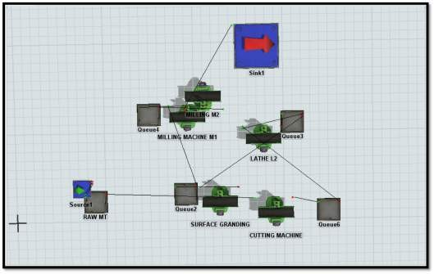
PROCESS LAYOUT USING SIMULATION SOFTWARE:

Fig 4.2: Boring Bar Process layout

THERE ARE FIVE PROCESSES FOR BORING BAR:
- Raw material cutting: First raw material is cutting as per drawing by sing cutting machine. This is used for only cutting purpose. Then send to next operation which is lathe machine
- Turning: Lathe machine that helps in shaping several material pieces in the desired shapes. The lathe is the machine which holds the work piece between two grid supports, called as centers. In lathe machine first job is held at center by using chuck key. Turning is the most common lathe machining operation. During the turning process, a cutting tool removes material from the outer diameter of a rotating work piece. The main objectives of turning is reduce the work piece diameter to the desired operation. After turning send to next operation jig boring process.

- Grinding: Surface grinding is used to produce a smooth finish on flat surfaces. Surface grinding is the most common of the grinding operations. It is finishing process that uses a rotating abrasives wheel to smooth the flat surface of metallic or nonmetallic to give them a more refined look by removing the oxide layer and impurities on work piece surfaces. This will also attain a desired surface for a functional purpose. Then send next operation ID grinding
- Milling: Milling process is the process of machining using rotary cutters to remove material by advancing a cutter into a work piece. This may be done varying direction on one or several axes, cutter head speed, and pressure. Milling cover a wide variety of different operations and machines it is one of the most commonly used process for machining custom parts to precise tolerance. Then next to send operation
- Drilling: Drilling is a cutting process that uses a drill bit to cut a hole of circular cross section in solid materials. The drill bit is usually a rotary cutting tool, often multi point. The bit is pressed against the work piece and rotated at rates from hundreds to thousands of revolutions per minute. This forces the cutting edge against the work piece, cutting off chips from the hole as it is drilled.
- Inspection: It is an inspection in the manufacturing process, and refers to the inspection performed in the final stage of manufacturing process.

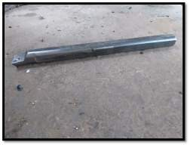

Fig 4.2.1: Boring bar

Sr. No | Machine 1 | Machine 2 | Distance between two machines (Meter) | Material travel time in second
1 | Cutting machine | Lathe machine L2 | 15 | 80
2 | Lathe machine L2 | Surface Grinding machine | 5 | 30
3 | Surface Grinding machine | Milling machine M1 | 9 | 25
4 | Milling machine M1 | Milling machine M2 | 2 | 14
Table 4.2.1: Machine to Machine distance data

Operation No | Machine Name | Processing Time  (Min) | Setup Time (Min) | Operation Type
1 | Cutting Machine | 5 | 5 | Setup Manual, Processing  Automatic
2 | Lathe Machine L2 | 15 | 5 | Setup Manual, Processing  Automatic
3 | Surface Grinding Machine | 50 | 10 | Setup Manual, Processing  Automatic
4 | Milling Machine  M1 | 60 | 30 | Manual
5 | Milling Machine  M2 | 15 | 5 | Manual
6 | Inspection | 15 | 20 | Setup Manual

Table 4.2.2: Machining data

SIMULATE EXISTING LAYOUT USING SIMULATION SOFTWARE:

The existing plant layout is designed by using flexsim simulation software. It clearly indicates that number of machines operators etc.
Give input data like processing and Setup time, machine distance for each machine which shown in Table 4.1.1 & 4.1.2.

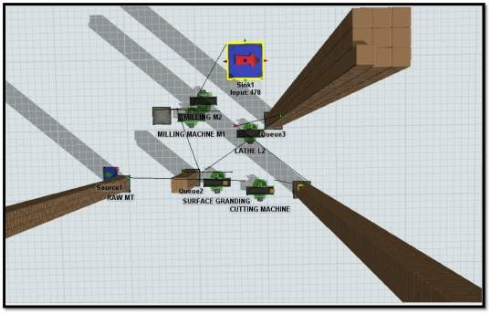

Fig 4.3: Existing plant layout

After simulating current layout using Flexsim software and applying input parameters, the existing layouts output production components is 478 in per month.

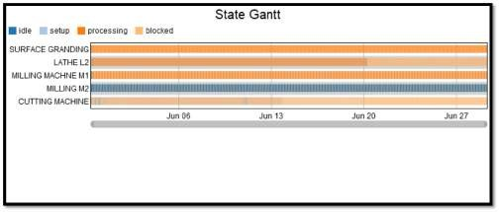
STATE GANTT CHART:

Chart 4.4 – State gantt chart

Gantt chart shows the different machines conditions for ideal, setup, processing etc.

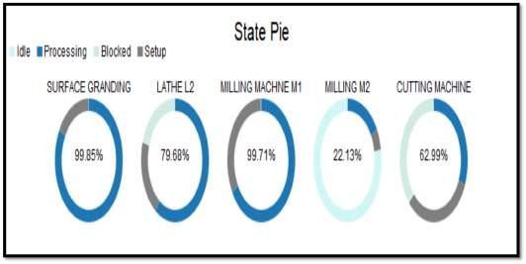
STATE PIE CHART:

Chart 4.5: State pie chart

 | Setup  (%) | Processing  (%) | Idle  (%) | Blocked  (%)
Surface grinding | 16.67 | 83.24 | 0.10 | -
Lathe machine L2 | 19.92 | 59.75 | 0.05 | 20.28
Milling machine M1 | 16.64 | 49.88 | 33.48 | _
Milling machine M2 | 8.31 | 24.93 | 66.76 | _
Cutting machine | 31.50 | 31.50 | 0.43 | 36.57

Table 4.5: Working machine in percentage

NEW DEVELOPMENT

After simulating modified layout using Flexsim software and applying all input parameters, the modified layouts output production components is 717 quantity per month.

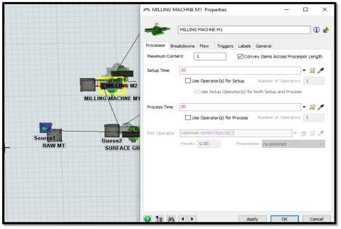
Fig 4.6: New development

MAXIMUM TIME CONSUMING:

Before add the hydraulic fixture in milling machine the setup time is 30 min and processing time is 60 min. and then after add the hydraulic fixture in milling machine the setup time is 10 min and processing time is 30 min.
Manufacturing new hydraulic fixture to minimize the setup time and processing time. Because of fixture design to achieve higher accuracy for the milling operation. It helps to decrease in cycle time, increase in production capacity, and reduction in manufacturing lead time.

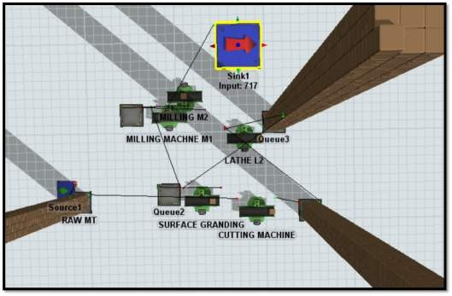
Fig 4.6.1: Maximum time consuming

FOUR HOLE RELATION GAUGE:

STEPS FOR FOUR HOLE RELATION GAUGE:

Gauging done in manufacturing process, refers to the method by which it is determined quickly whether or not the dimension of the checking parts in production are within their specified limits. It is done with the help of some tools called gauges. A gauge does not reveal the actual size of dimension. Gauges are the tools which are used for checking the size, shape and relative positions of various parts but not provided with graduated adjustable members, gauges are therefore, understood to be single size fixed type measuring tools. Material used for the gauge EN31, plate, guide pin, gauge pin linear.

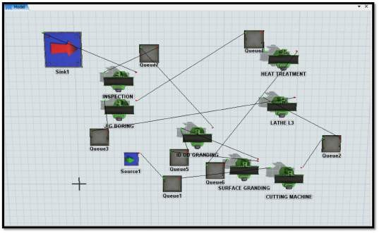
PROCESS LAYOUT BY USING SIMULATION SOFTWARE:

Fig 4.8: Process layout by using simulation software

The existing plant layout is designed by using Flexsim simulation software. It clearly indicates that number of machines operators etc.

THERE ARE EIGHT PROCESSES FOR FOUR HOLE RELATION GAUGE:
- Raw material cutting: First raw material is cutting as per drawing by sing cutting machine. This is used for only cutting purpose. Then send to next operation which is lathe machine.
- Turning: Lathe machine that helps in shaping several material pieces in the desired shapes. The lathe is the machine which holds the work piece between two grid supports, called as centers. In lathe machine first job is held at center by using chuck key. Turning is the most common lathe machining operation. During the turning process, a cutting tool removes material from the outer diameter of a rotating work piece. The main objectives of turning are reduce the work piece diameter to the desired operation. After turning send to next operation jig boring process.
- Jig boring: Jig boring is a machine which is used for accurate sizing of hole. This is advanced automation technology machine. This machine is used for special purpose that boring and done holes. Jig boring machine works on the principle of feed in the vertical axis of the hole and its radius. In this process rotating tool is moved over the process is given with respect to static work. Then send to next operation hardening.
- Hardening: The most common heat treatment process of all, hardening is used to increase the hardness of a metal. In some cases, only the surface may be hardened. Firstly the material is kept inside the furnace. Then required temp 850c of hardening is set on the display. The maximum temperature of hardening is 1000c. The gradually obtained the require of temperature of hardening. After that work piece is removed from the furnace. Then work piece is placed in oil. After 5 min work piece is removed from oil and its hardness is check by hardness tester. Then send to next operation surface grinding.
- Surface grinding: Surface grinding is used to produce a smooth finish on flat surfaces. Surface grinding is the most common of the grinding operations. It is finishing process that uses a rotating abrasives wheel to smooth the flat surface of metallic or nonmetallic to give them a more refined look by removing the oxide layer and impurities on work piece surfaces. This will also attain a desired surface for a functional purpose. Then send next operation ID grinding.
- ID grinding: ID grinding (Internal diameter grinding). Internal grinders are used to finish straight, tapered or formed holes accurately. The most popular internal grinding is similar in operation to a boring operation in a lathe. The work piece is held by a work holding device, usually a chuck or collect, and revolved by a motorized head

stock. A separate motor head in the same direction as the work piece revolve the grinding wheel. It can be fed in and out of the work and also adjusted for depth of cut.
- OD grinding: OD grinding is grinding occurring on external surface of an object between the centers. The centers are end units with a point that allow the object to be rotated in the same direction when it comes in contact with the object. This effectively means the two surfaces will be moving opposite directions when contact is made which allows form smoother operation and less chance of jam off. And then send to finale operation is assembly and inspection.
- Assembly & Inspection: the assembly process is an arrangement of machines, equipment, and workers where the product to be assembled passes sequentially from one operation to another until complete. It is an inspection in the manufacturing process, and refers to the inspection performed in the final stage of manufacturing process.

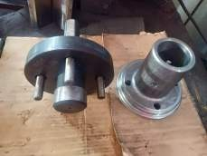

Fig 4.8.1: Four hole relation gauge

Op. no | Machine name | Setup time (Min) | Processing time  (Min) | Operation type
1 | Cutting machine | 10 | 60 | Setup manual, processing automatic
2 | Lathe machine L3 | 15 | 60 | Setup manual, processing automatic
3 | jig boring machine | 20 | 90 | Setup manual, processing automatic
4 | Heat treatment in furnace | 2 | 240 | Setup manual,
5 | Surface grinding machine | 5 | 90 | Setup manual, processing automatic
6 | ID& OD grinding | 20 | 90 | Setup manual, processing automatic
7 | OD grinding | 15 | 60 | Setup manual, processing automatic
8 | Assembly & Inspection | 5 | 60 | Setup manual
Table 4.8.1: Machining data

Sr.  No. | Machine name 1 | Machine name 2 | Distance between two machines (Meter) | Material travel in time in second
1 | Cutting machine | Lathe machine L3 | 10 | 60
2 | Lathe machine L3 | Jig boring machine | 18 | 95
3 | Jig boring machine | Heat treatment in furnace | 17 | 75
4 | Heat treatment in furnace | Surface grinding machine | 12 | 35
5 | Surface grinding machine | ID & OD grinding machine | 4 | 20
6 | ID & OD grinding machine | OD grinding machine | 5 | 25
7 | OD grinding machine | Assembly & Inspection | 9 | 30
Table 4.8.2: Machine to Machine distance

The above tables give input data like processing time, setup time, operation type, machine name which shown in table.

SIMULATE EXISTING LAYOUT USING FLEXSIM SOFTWARE:

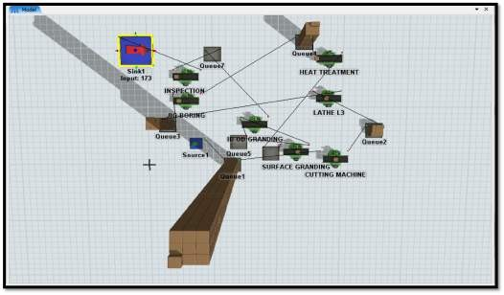
Fig 4.9: Existing plant layout

After simulating current layout using Flexsim software and applying input parameters, the existing layouts output production components is 173 in per month.

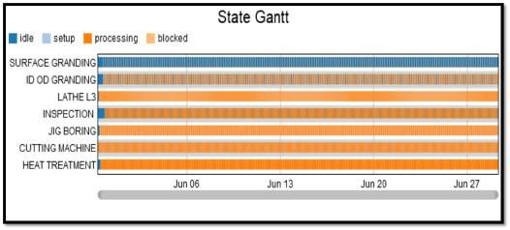
STATE GANTT CHART

Chart 4.10: State gantt chart

Gantt chart shows the different machines conditions for ideal, setup, processing etc.

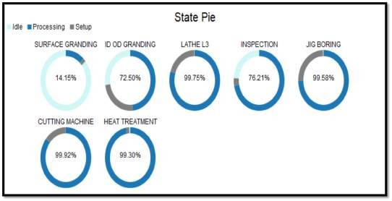
STATE PIE CHART:

Chart 4.11: State pie chart

 | Setup  (%) | Processing  (%) | Idle  (%)
Surface grinding | 3.97 | 23.82 | 72.21
ID & OD grinding | 33.06 | 65.93 | 1.01
Lathe machine L3 | 19.97 | 79.85 | 0.19
Inspection | 5.21 | 93.37 | 1.43
Jig boring | 24.93 | 74.71 | 0.36
Cutting machine | 14.28 | 85.69 | 0.03
Heat treatment in furnace | 3.98 | 95.38 | 0.64

Table 4.11: Working machine in percentage

  - NEW DEVELOPMENT

In this manner the system produces 223 products per month.
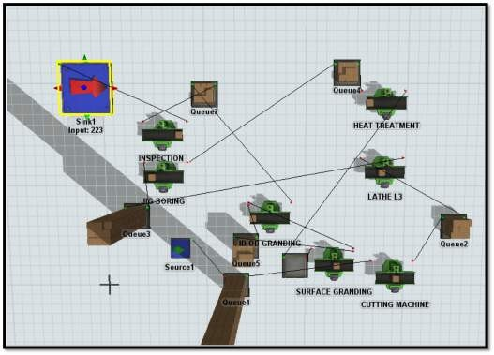

Fig 4.12: New development

    - MAXIMUM TIME CONSUMING

Before send to the company product for hardening process total setup time for this existing system is about 60 min. and processing time is around 4 hours.
By using Flexsim simulation software we are not going to add any machine but, for heat treatment process half of the total number of products are

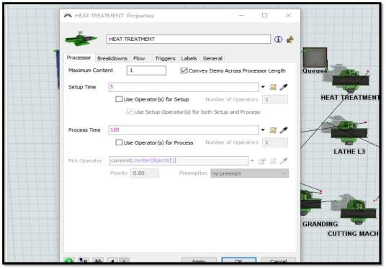
send to another company. And then setup rime for hardening process is 5 min and processing time is 30 min.

Fig 4.12.1: Maximum time consuming

CHAPTER 5 RESULTS

RESULTS ANALYSIS

Now we are looking for the result to know the advantages.

BORING BAR:

Layout | Remarks | Production quantity
Existing | Simulation is done as per current layout | 478
1st Iteration | Instead of adding new process & ideas. | 717
Table 5.1.1: Result for boring bar

In this system these are five machines are used. They are 1) Cutting machine

  - Lathe machine L2

  - Surface grinding machine

  - Milling machine M1

  - Milling machine M2

Total set up time for this existing system is about 75 min and processing time is around 160 min. Similarly, simulation done on remaining one component. In such way these system produces 478 products in one month period. But then we use Flexsim simulation software to change the layout system and according to these change a hydraulic fixture is add to milling machine M1. Because of fixture design to achieve higher accuracy for the milling operation. It helps to decrease in cycle time, increase in production capacity, and reduction in manufacturing lead time.
Before add the hydraulic fixture in milling machine the setup time is 30 min and processing time is 60 min. and then after add the hydraulic fixture in milling machine the setup time is 10 min and processing time is 30 min. In this manner the system produces 717 products per month and productivity increase by 50%.

FOUR HOLE RELATION GUAGE:

Layout | Remarks | Production quantity
Existing | Simulation is done as per current layout | 173
1st Iteration | Instead of adding new process & ideas. | 223
Table 5.1.2: Result for Four hole relation gauge

Similarly, simulation done on four hole relation gauge. Time required for heat treatment is around four hours. According to these 173 products are produces per month. By using Flexsim simulation software we are not going to add any machine but, for heat treatment process half of the total number of products are send to the another company. In this way total 223 products are produced per month. And productivity increases by 28%.

PROFIT COMPARISON AND INCREASE IN PROFITABILITY TABLE:

    - BEFORE SIMULATION

Product name | Boring bar | Four hole relation gauge
Total product quantity | 478 | 173
Profit per job | 1500 | 2000
Monthly profit | 717000 | 346000

Table 5.2.1: Before simulation

Before using simulation total 478 products are manufactured per month for boring bar and profit per job is around 1500. Hence monthly profit is 717000. And for four hole relation gauge before using simulation total 173 products are produced per month and profit per job is around 2000. Hence monthly profit is 346000.

AFTER SIMULATION

Product name | Boring bar | Four-hole relation gauge
Total product quantity | 717 | 223
Profit per job | 1500 | 2000
Monthly profit | 1075500 | 446000
Table 5.2.2: After simulation

After simulation as time reduces and hence number of products per month increases. Boring bar is produces per month is 717 products. And four-hole relation gauge is produces per month is 223 products. Profit per job is same as system without simulation i.e. 1500 Rs. & 2000 Rs.
But the net monthly profit increases 1075500 for boring bar and 446000 for four-hole relation gauge.

PROFIT COMPARISON

Particular | Boring Bar | Four Hole Relation Gauge
Total increment in profit | 358500 | 100000
Cost of implementation | 200000 | 100000
Cost pays back 25% of  increment profit | 89625 | 25000
Payback period in the month | 2.2 | 4
Table 5.2.3: Profit comparison

Total increment in profit for boring bar is 358500 and total increment in profit for four-hole relation gauge is 100000.
The cost of implementation means the cost for the hydraulic fixture is 200000 and the cost for products sent to another company is 100000.
The cost pays back 25% of increment profit for the boring bar is 89625 and for the four-hole relation gauge is 25000.
The payback period for the boring bar is 2.2 months and for the four-hole relation gauge is 4 months.

CHAPTER 6: CONCLUSION

As per the results of the two components' output, we concluded that by analyzing the parameters like manpower, machine process time, machine setup time, layout, production rate, etc. Simulation software gives the information about effect of modification of system layout. However, reduces processing time, reduces material movement, increases space, a backtracking issue, etc. Optimizing Flexsim software the performance of one iteration is calculated.
It is noticed that 1st iteration gives better productivity and improves the performance than the existing layout. Finally, the paper shows the improved and optimized better machine system layout with the help of Flexsim software.

CHAPTER 7 REFERENCES

- Prof. Devendra A. Pathak et al., Improvement of Manufacturing Process by Simulation Technique: A Case Study ternational Journal of Advances in Science and Technology, Vol. 4, No.4, 2012
- Jannatul Shefa et al., (2018). Simulation modeling for productivity improvement of a production line.
- Betterton, C.E., (2016). Identification of production bottlenecks with the use of plant simulation software.
- Sepideh Khalafi et al., (2015). Productivity improvement in a windows manufacturing layout using Flexsim simulation software.
- Endra Joelianto and Linda Kadarusman. (2009). “Industrial Control Quality Improvement using Statistical Process Control: Tennessee Eastman Process Simulation Case” Bandung Institute ofTechnology Jalan Ganesha 10, Bandung 40132, Indonesia. International Conference on Instrumentation, Control & Automation ICA2009October 20-22, Bandung, Indonesia, 2009 ICA, ISBN.
- Kana Yokoyama, Katsumi Morikawa, and Katsuhiko Takahashi. (2010). “A modified multi agent system for simple assembly line balancing, 8th International Conference of Modeling and Simulation.
- Ahmadi, R.H., & Tang, C.S. (1992). The dynamic line allocation problem. Management Science.38(9),1341-1353
- Betterton, C. E., & Silver, S. J. (2012). Detecting bottlenecksin serial production lines-a focus on interdeparture time variance. International Journal of Production
- Law A. M. (2008). How to build valid and credible simulation models. Proceedings of the 40th Conference on winter simulation.
- Wnag, Y., Zhao, Q., & Zheng, D. (2005). Bottleneck in production networks: An overview. Journal of Systems
- Ondrej Kurkin and Michal Simon, Optimization of Layout Using Discrete Event Simulation, IBIMA Business Review, Vol. 2011 (2011)

- [7] Qi Hao, Weiming Shen, Implementing a Hybrid Simulation Model for a Kanban- Based Material Handling System, Robotics and Computer-Integrated Manufacturing, 24, (2008), pp. 635–646.
- William B. Nordgren, Flexsim Simulation Environment, Proceedings of the 2003 Winter Simulation Conference.
- Xiaofeng Hu, Ruxiao An, Modeling and Simulation of Manufacturing Systems in Unstable Environment, Proceedings of the World Congress on Engineering 2011, Vol. I, WCE 2011, July 6-8, 2011.

    - PAPER PUBLICATION

    - PROJECT GROUP PHOTOGRAPH
(Insert one color photograph here with the project demo, group members, and Guide)

Image: Group Photo of “Project title”

